ECEN 214

Lab 3 Report

Measurements Taken:

10/02/2019

Due: 10/09/2019

Jason Gilman

Christopher Smith

Section 508

Saad Muaddi

**Procedure**

Task 1:

We set up the circuit from Figure 3.4 on our breadboard and used the Analog Discovery 2 to produce our initial voltage of 3 VDC. We also used the Analog Discovery 2 to measure the voltage drop across the load resistor using three different values: 2000 Ω, 5100 Ω, and an open circuit (infinite resistance). The measurements we got can be found below in the “Task 1 Table”. We then compared our measurements and compared them to the calculated Thevenin measurements, which is explained below in the Calculations segment.

Task 2:

We set up the circuit from Figure 3.5 on our breadboard and used the Analog Discovery 2 to produce our initial voltages of 3 and 4 VDC. With both voltages connected to our circuit, we measured the voltage drop across the 1000 Ω resistor. Afterwards, we removed the 3 VDC source from the circuit and measured the voltage drop across the 1000 Ω resistor. Finally, we reconnected the 3 VDC source and removed the 4 VDC Source from the circuit, and once again measured the voltage drop across the 1000 Ω resistor. By removing one of the voltage sources, we were utilizing the superposition principle. Our measurements can be found below in the “Task 2 Table”.

Task 3:

We set up the circuit from Figure 3.6 on our breadboard and used the Analog Discovery 2 to produce our initial voltages of 3 and 4 VDC. This circuit is the same as the circuit in task 2, except there is a non-linear device added: a diode. We took the exact same measurements across the 1000 Ω resistor with the same configuration of voltage(s) connected to the circuit. Our measurements can be found below in the “Task 3 Table.”

**Data**

**Task 1 Table**

Source Measured: 3.013 VDC

Source Theoretical : 3 VDC

$V_{TH}=1.626$ VDC

|  |  |
| --- | --- |
| $R_{L}$ | $V_{L}$ |
| 2000 Ω | .778 VDC |
| 5100 Ω | 1.144 VDC |
| ∞ Ω (Open Circuit) | 1.626 VDC |

**Task 2 Table**

$V_{1}=4.006$ V $V_{2}=2.986$ V

|  |  |  |  |  |  |
| --- | --- | --- | --- | --- | --- |
| Parameter | Measured | Calculated | % Diff | SPICE | % Diff (Spice) |
| $V_{L}$ | .269 VDC | .2623 VDC | 2.52 % | .267 VDC | 0.746 % |
| $V_{L,1}$ | -.288 VDC | -.2927 VDC | 1.61 % | -.290 VDC | 0.692 % |
| $V_{L,2}$ | .556 VDC | .556 VDC | 0.000 % | .558 VDC | 0.359 % |
| $V_{L,1 }+V_{L,2}$ | .268 | .2633 VDC | 1.769 % | .268 VDC | 0.000 % |

**Task 3 Table**

$V_{1}=4.006$ VDC $V_{2}=2.986$ VDC

|  |  |  |  |  |
| --- | --- | --- | --- | --- |
| Parameter | Measured | Calculated | SPICE | % Error |
| $V_{L}$ | -.004 VDC | 0 VDC | -1.04991E-9 VDC | 200 % |
| $V_{L,1}$ | -.154 VDC | .0033 VDC | -.134 VDC | 13.88 % |
| $V_{L,2}$ | -.004 VDC | 0 VDC | -2.17667E-9 VDC | 200 % |
| $V_{L,1 }+V_{L,2}$ | -.158 VDC | .0033 VDC | -.134 VDC | 16.43 % |

**Calculations**

In part 1, to calculate the Thevenin Equivalent voltage, we left the circuit open across the load. This resulted in $V_{TH }= 1.626$ V. We then put a 2k resistor across the load to measure the voltage across the load. We repeated this procedure with a 5.1k resistor as well.

In part 2 and part 3, we set up a circuit that contained two sources, and the goal was to find the voltage across a particular resistor, when it was receiving voltage from both, and one of each sources. This was to test the superposition principle. To do this we used a voltmeter,and shorted each source at a time to find the corresponding data values. To find the calculated values in the second data table, the following equations were used:

KCL :

$(V_{1}-V_{2})/1000 + V_{1}/5100 + V_{1}/2000 = 0$

$(V_{2}-V_{S1})/5100 + V_{2}/2000 + (V_{2}-V_{1})/1000 =0$

This was to achieve node voltages for shorting the 3V source. The same procedure was completed for the second source. This gave us currents for each source cancelled. To test the superposition principle, the following equation was used:

$I_{1}+I_{2}=I$

Where I is the current across the same resistor, but being supplied by both sources. With this information, we were able to make a simple calculation of voltage across the 1k resistor by using:

$V =IR$

$V = I_{1,2, or I} (1000)$

This gave us the values that occur in the data table under calculations.

**Screen Shots from the Tasks**

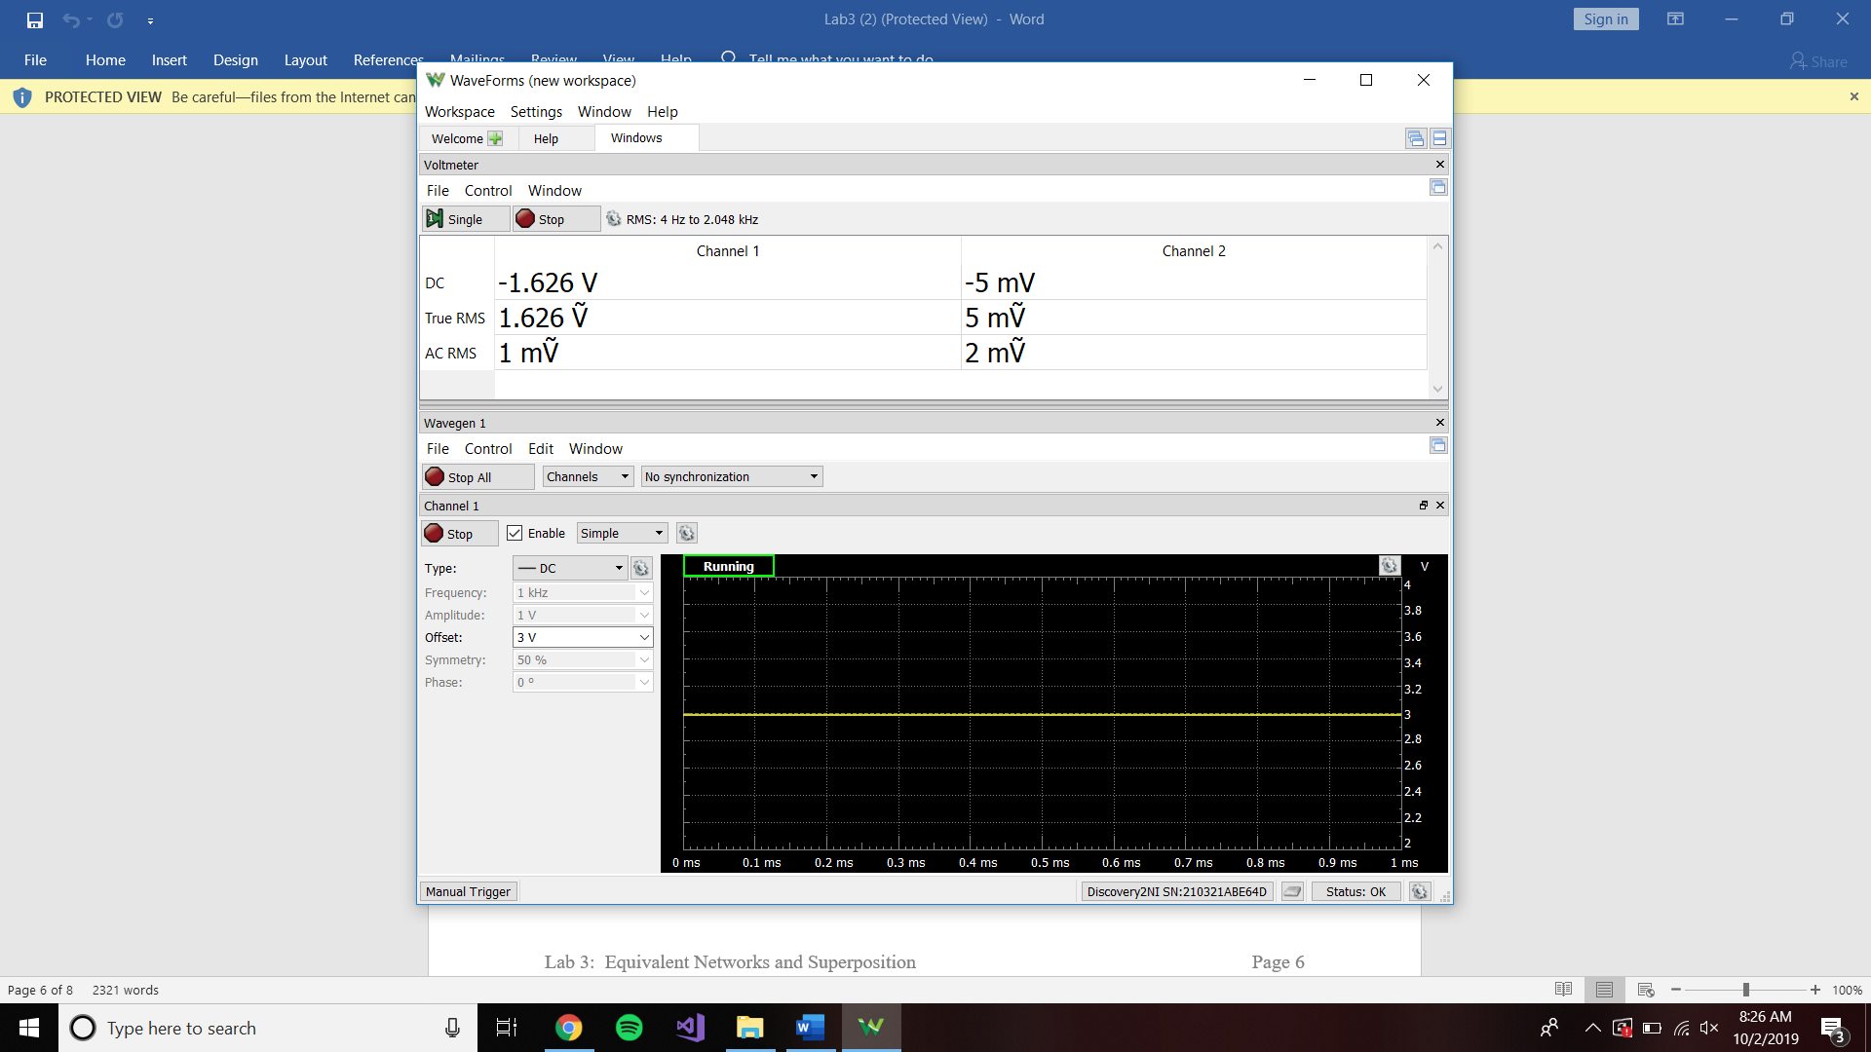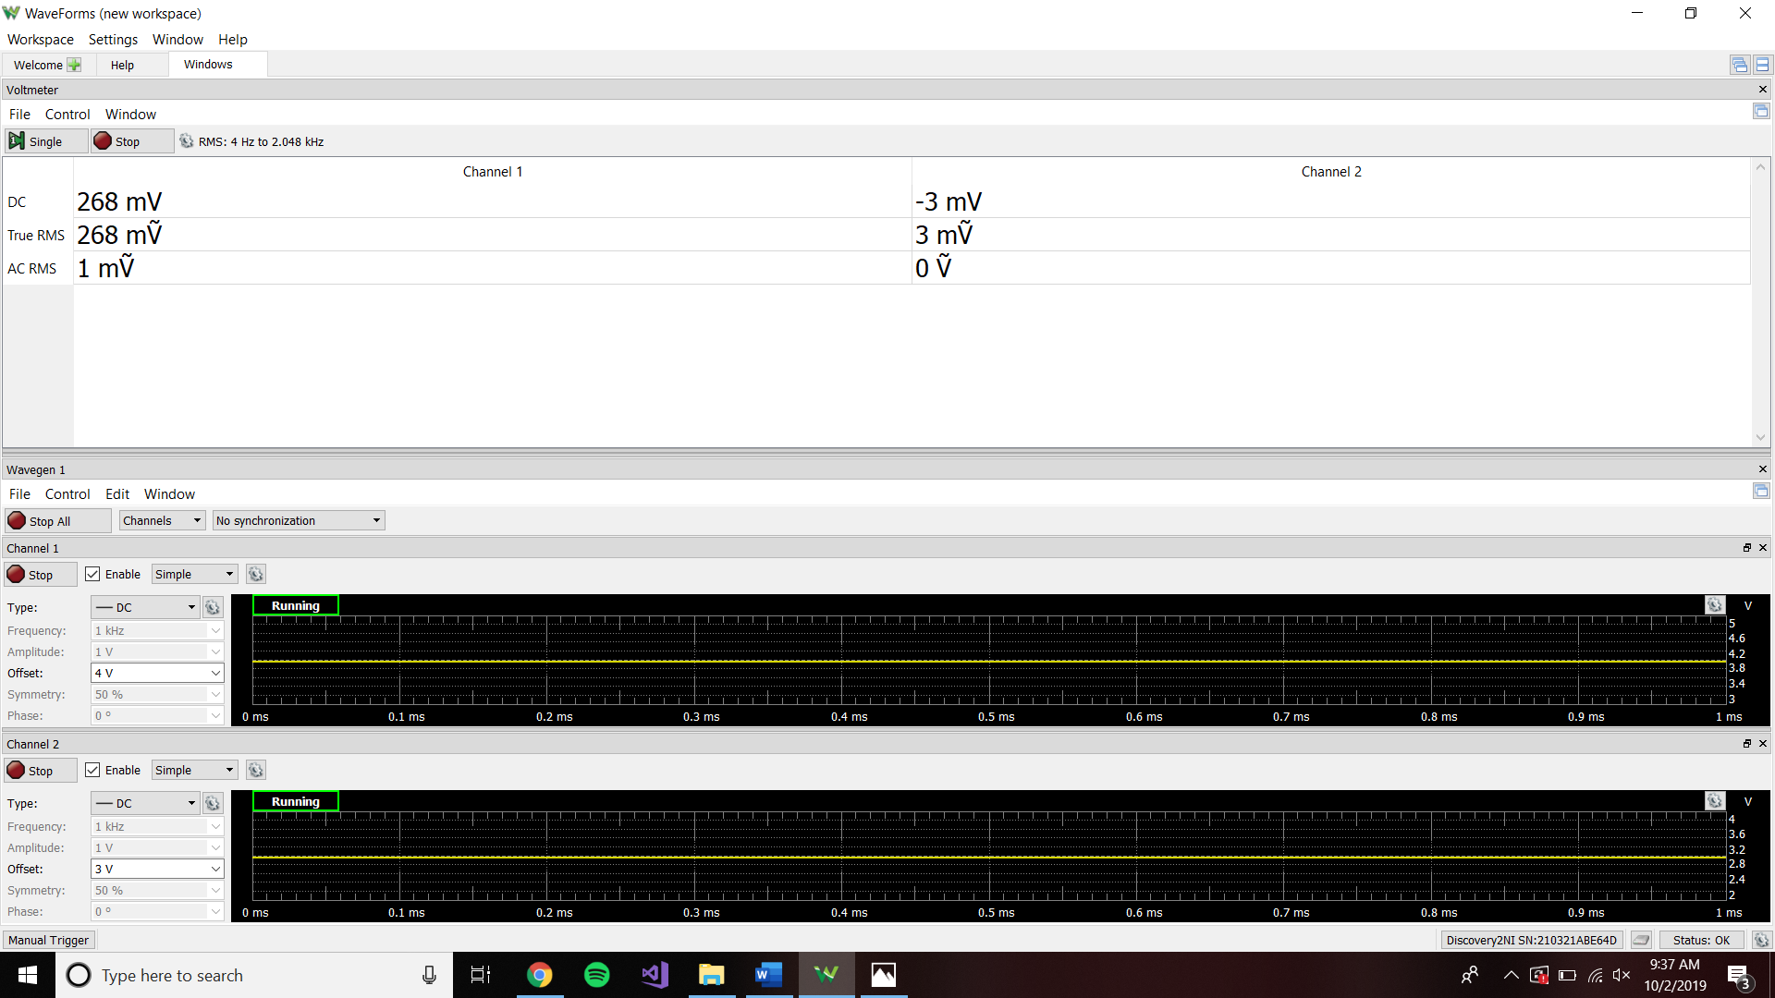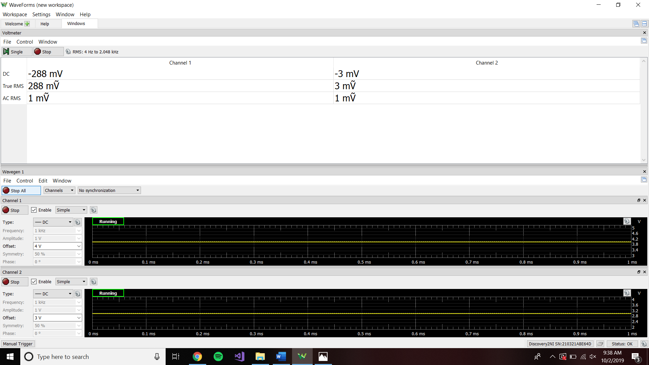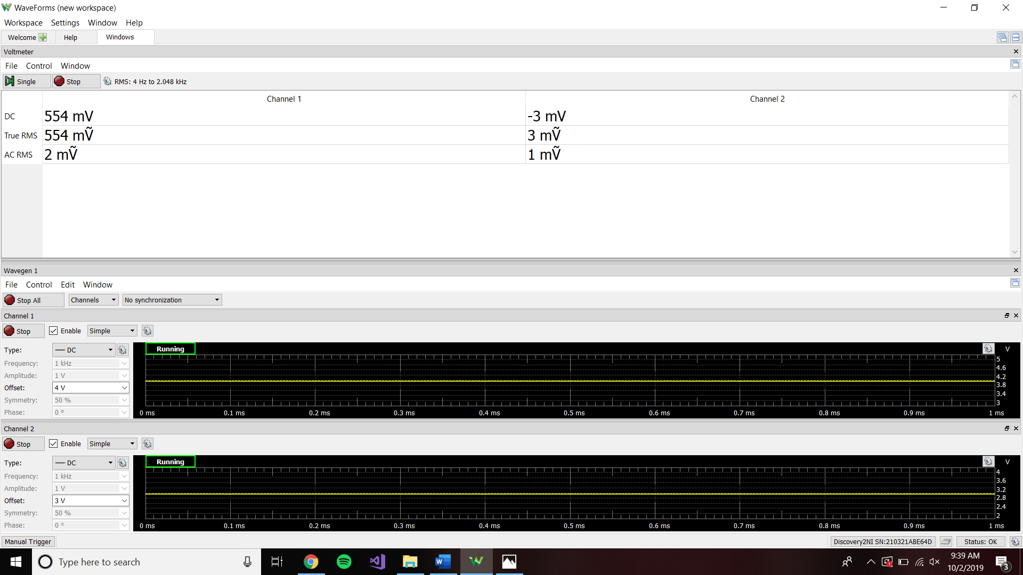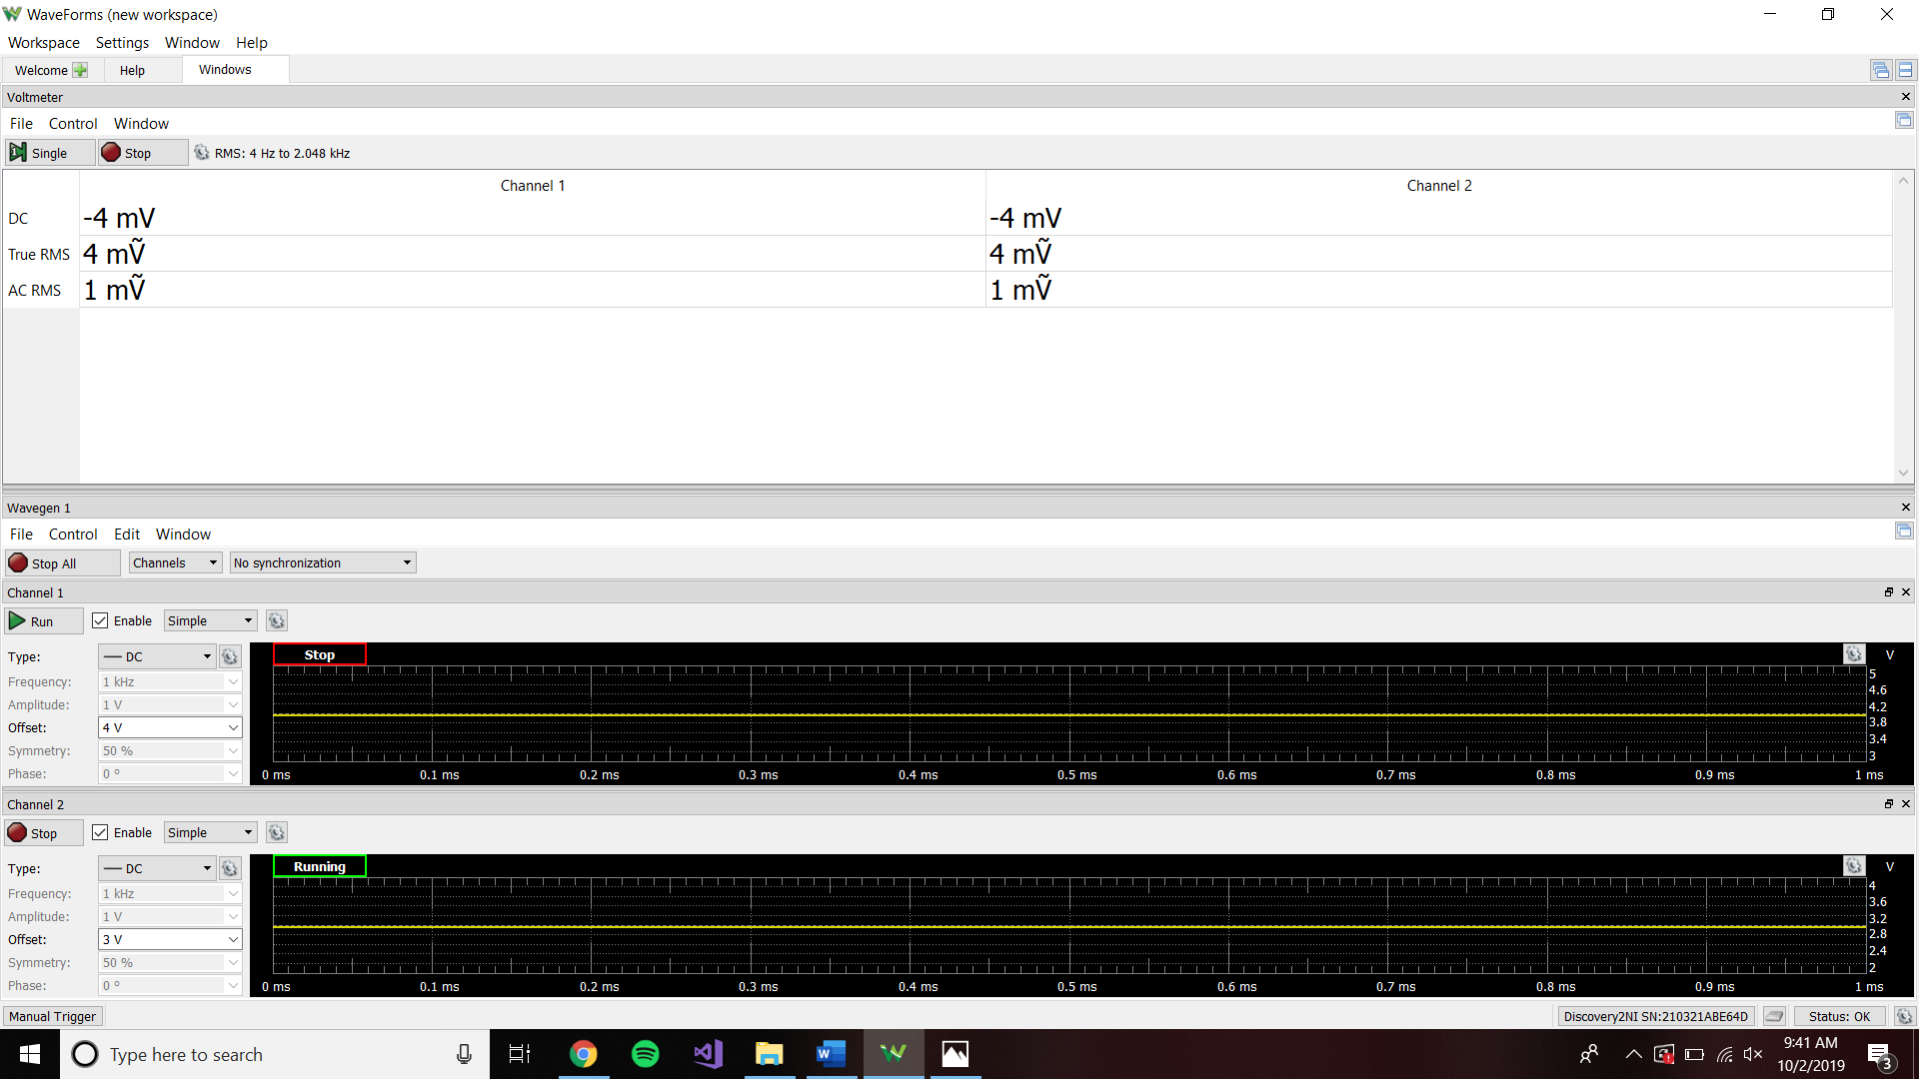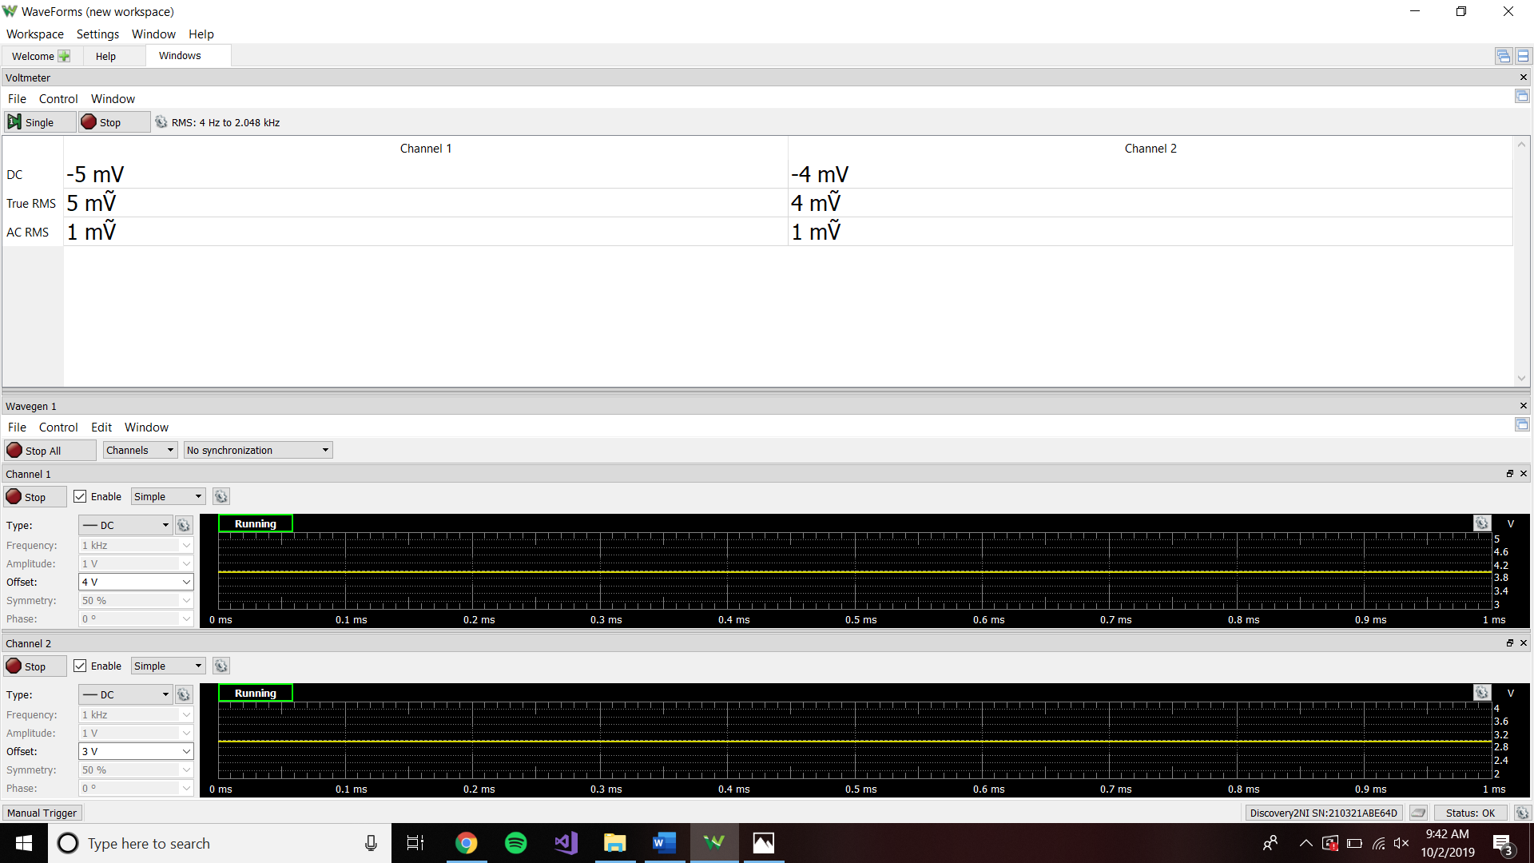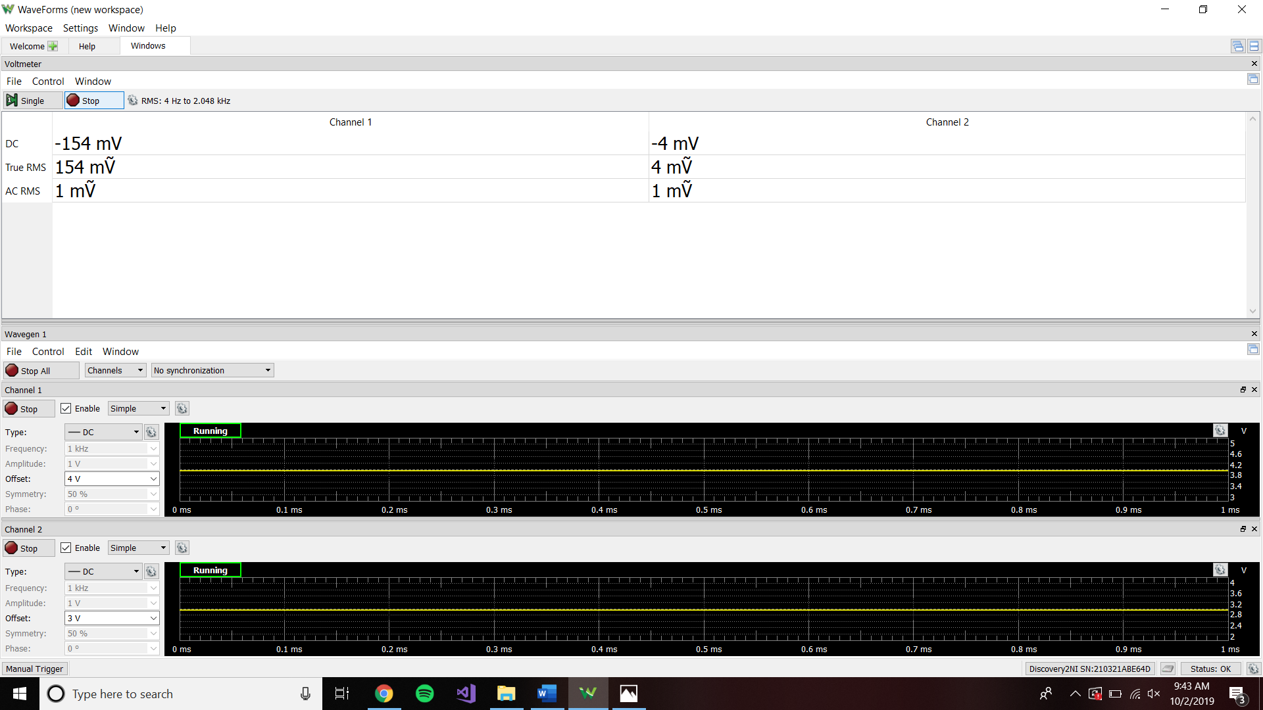

**Discussion**

Task 1:

For the model, we removed the load resistor and measured the voltage drop across the open circuit. We then took a wire and connected it across where the load resistor was supposed to be and measured the current. Using the current and voltage, we were able to calculate the Thevenin equivalent.

Tasks 2 & 3:

The superposition principle worked in task 2, but not task 3. Task two only used linear elements in the circuit as opposed to task 3 which used a diode (non-linear device). A diode only allows current to flow one way, making the superposition principle not applicable in task 3. However, resistors do allow current to flow in either direction, which makes them linear.

**Conclusion**

This lab was once again straight forward. It was great to actually see Thevenin and superposition work on an actual circuit. There were no major issues that occurred.